|  |  |  |
| --- | --- | --- |
|  | **Jefferson County School System**  Dr. Samuel D. Dasher, Jr., Superintendent  1001 Peachtree Street  Louisville, GA 30434  Telephone 478/625-7626  Fax 478/625-7459  E-Mail: dashers@jefferson.k12.ga.us | **Board of Education**  James E. Fleming, Jr.  Chairman  Farlyn Hudson  Vice Chair  **Members**  Teresa Brooks  Steve Norton  Julia Wells |

**July 18, 2023**

**Right to Know Professional Qualifications of Teachers and Paraprofessionals**

Dear Parent(s)/Legal Guardian(s):

In compliance with the requirements of the Every Students Succeeds Act (ESSA), the Jefferson County School System would like to inform you that you may request information about the professional qualifications of your student’s teacher(s) and/or paraprofessional(s). The following information may be requested:

* Whether the student’s teacher(s) –
* has met State qualification and licensing criteria for the grade levels and subjects areas in which the teacher provides instruction;
* is teaching under emergency or other provisional status through which Sate qualification or licensing criteria have been waived; and
* is teaching in the field of discipline of the certification of the teacher.
* Whether the child is provided services by paraprofessional(s), and, if so, his/her qualifications.

If you wish to request information concerning the professional qualifications of your child’s teacher(s) and/or paraprofessional(s), please contact your child’s principal at the following:

|  |  |  |  |
| --- | --- | --- | --- |
| Carver Elementary | Mr. Melvin Farmer | (478) 252-5762 | farmerm@jefferson.k12.ga.us |
| Louisville Academy | Mrs. Tina Ethridge | (478) 625-7794 | ethridget@jefferson.k12.ga.us |
| Wrens Elementary | Mrs. Jessica Howard | (706) 547-2063 | howardj@jefferson.k12.ga.us |
| Jefferson Co. Middle | Ms. Moya Pope | (478) 625-7764 | popem@jefferson.k12.ga.us |
| Jefferson County High | Mr. Carl Prescott | (478) 625-9991 | prescottc@jefferson.k12.ga.us |

If you have questions or need further information, you may contact me at (478) 625-7626 or email me at [arnolds@jefferson.k12.ga.us](mailto:arnolds@jefferson.k12.ga.us).

Sincerely,

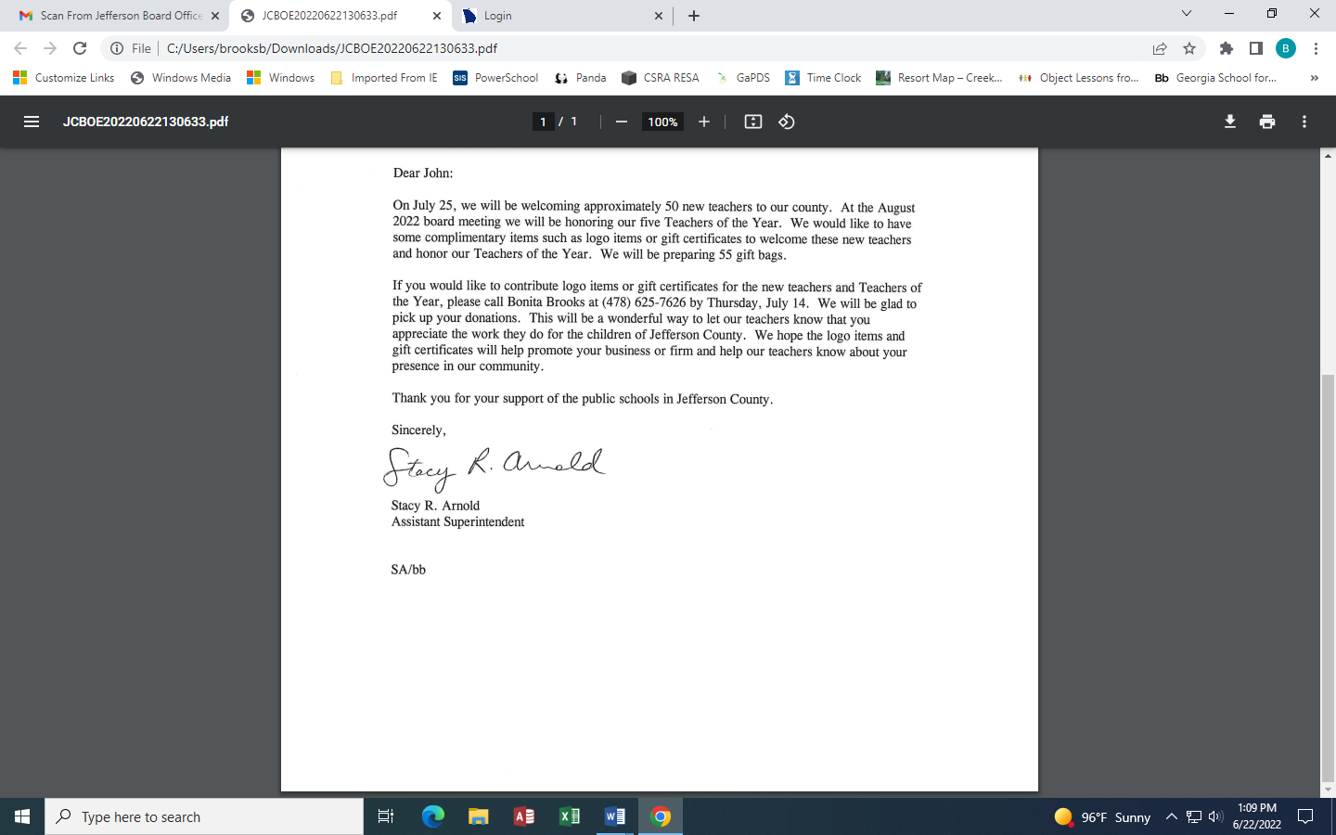

Stacy R. Arnold

Assistant Superintendant